Bad Homburg, 18.11.2021

SKY POWER GmbH COLLABORATES WITH ZEROSUM TECHNOLOGIES IN INDIA
The world leader in UAV engine technology, Germany based Sky Power GmbH has tied up with Zerosum Technologies, India to provide class leading UAV propulsion systems to the local growing and maturing market. The relationship between the two companies is expected to go beyond marketing the Sky Power products. Mr Karsten Schudt, Managing Director of Sky Power said, “India is a unique and growing market for UAVs due to recent legislative changes. We are looking to understand the local customer requirements and develop solutions specific to India.” Zerosum Technologies is looking to set up a center to provide engine testing facility locally and also to maintain spare parts in India so as to quickly meet the after sales requirements. As per Mr Jai Sharma, Head Marketing of Zerosum “India requires technology infusion from the best in class companies to accelerate the process of being ‘Atma-nirbhar’ in the UAV domain. Sky Power GmbH is a world leader in two stroke and wankel propulsion systems and future engine development technology, which fits our company's mission to meet the increase in demand for right products.” The company is looking to assemble the engines locally if there is adequate demand from the Indian customer.

Sky Power and Zerosum will be providing end-to-end solutions for UAV systems from 25 up to 150kg MTOW in varying configurations with TRL9 solutions and decades of industry experience consisting of complex international projects, global supply chain management, industry leading precision engineering and unrivalled quality control to ensure the best-in-class engine systems.
About Sky Power
Sky Power International is a leading manufacturer of 2-stroke combustion- and Wankel engines for UAS (Unmanned Aerial Systems) and hybrid applications. Besides in-house development and manufacturing, Sky Power International produces all engines in Germany. Custom adaptations, new developments and continuous performance improvements of the combustion engines are ongoing company objectives. More information: www.skypower.online
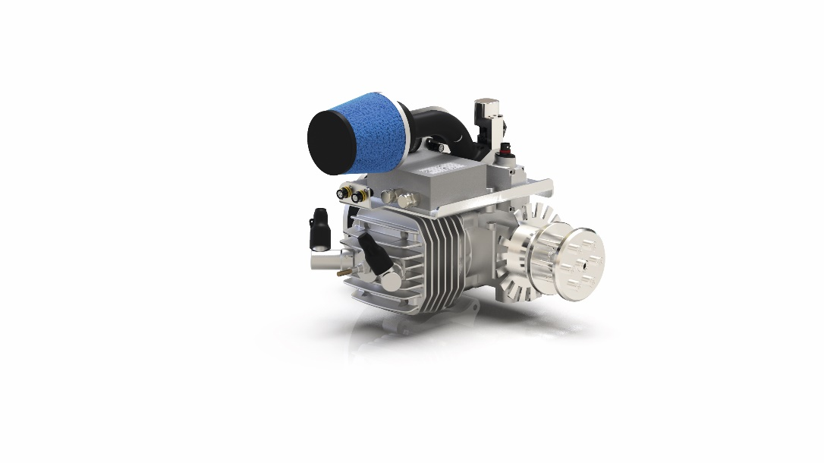

Picture captions:
SP-55 FI TS ROS

Deeplinks:
https://skypower.online/

Press Contact
Sky Power GmbH
Hollerstraße 12
61350 Bad Homburg
fs@skypower.online
Phone: +49 (0) 176 82332548
www.skypower.online

