Bad Homburg, 30.11.2021

Sky Power's SP-180 SRE hybrid wankel propulsion system now available for HF applications

Sky Power International's SP-180 SRE single-disc wankel engine is now offered for heavy fuel (HF) applications. This wankel engine is a hybrid electric motor with a compact design and class leading power-to-weight ratio. It was first introduced to the industry in 2017 and has since been installed in a wide range of drone applications.

The heavy fuel SP-180 HF SRE is a modified version of the original gasoline engine. This modification includes the SP-180 SRE with all auxiliaries and the additional of preheating equipment to compensate for the higher flash point of kerosene, and to maintain cold start capability. Thus, the engine is equipped with the kerosene heater control unit (KHU100), the engine/water preheater (WPH100) and the fuel preheater (FPH100). The KHU100 controls the complete fuel and engine preheating process before, during and after operation. This unit heats the fuel preheater cover as well as the WPH100. The WPH100 is used as a heater to preheat the engine's water-cooling circuit. For operation, the heavy fuel SP-180 SRE needs a kerosene/oil mixture with a ratio of 200:1 (Jet A1 : Aspen 2-stroke oil). Engine cooling is provided by water cooling of the housing and oil cooling of the rotor, allowing reliable operation under severe environmental conditions.

The heavy fuel SP-180 HF SRE can be operated as a direct drive, hybrid application or in an electrical power generation mode. With hybrid boost power, an additional 15KW is optionally available for direct drive, depending on the capacity of the on-board battery. Conventional generators as well as starter generators are available depending on customer application and requirements with the latter having to be connected to a 48V battery pack with the preheater unit. The capacity and peak current of the battery must be large enough to supply the current required to preheat the engine and start the combustion cycle.

"Heavy fuel engines have a long history with us, as we have been offering our two-stroke engines in this configuration for a very long time. Now, we are pleased to be able to use our wankel engine for this fuel type, as well for military applications, notable the NATO single fuel policy," explains Karsten Schudt, Managing Director of Sky Power GmbH. The development of the heavy fuel SP-180 SRE was due to the increasing demand from the market, requiring a power dense, frugal, and reliable heavy fuel system.

About Sky Power
Sky Power International is a leading manufacturer of 2-stroke internal combustion and wankel engines for UAS (Unmanned Aerial Systems) and hybrid applications. In addition to in-house development and manufacturing, Sky Power International produces all engines in Germany. Customization, new developments, and continuous performance improvements of the combustion engines are constant company development objectives.
More information: www.skypower.online

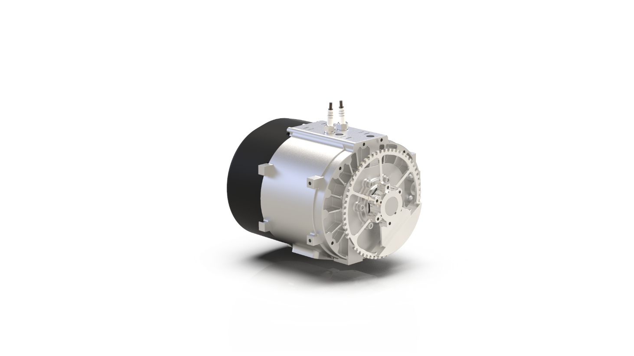

Picture captions:
Heavy fuel SP-180 HF SRE

Deeplinks:
https://3w-international.com/produkt/sp-180-hf-sre/

Press Contact
Sky Power GmbH
Hollerstraße 12
61350 Bad Homburg
fs@skypower.online
Phone: +49 (0) 176 82332548
www.skypower.online

