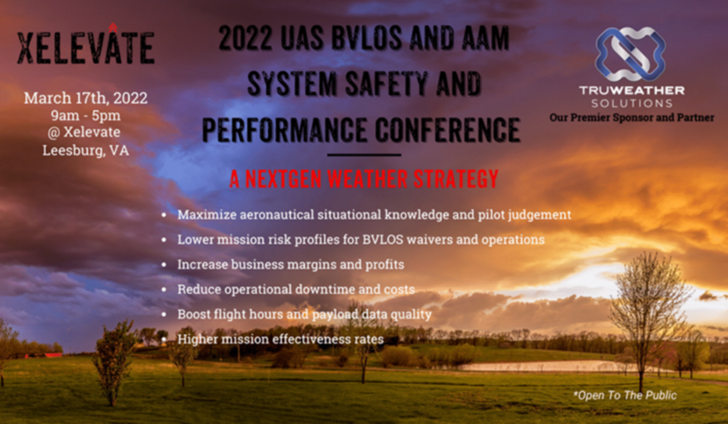
The First Hybrid Weather Conference for UAS/AAM Operations Hosted by TruWeather and Xelevate
Using Advanced Weather Technology and Techniques to Build Resiliency in Drone & eVTOL Ops
Reston, VA, March 2, 2022 - TruWeather Solutions, along with partner Xelevate, Unmanned Systems Center of Excellence, will be hosting the BVLOS and AAM System Safety and Performance – A NextGen Weather Strategy Conference on March 17th, 2022, in Leesburg, VA. This will be a one-day hybrid event, in-person at the Xelevate Center and online for a virtual experience, recorded for those that cannot tune in for the entire day.
The event will educate attendees about micro-weather challenges that impact the scaling of drone operations and provides insights into low-cost weather sensors and weather decision tools available to mitigate weather risks. The speakers will also discuss methods for introducing a discipline approach to weather risk management in day-to-day ops. The goal is for UAS Program Managers and operators to appreciate the importance of building a disciplined UAS weather program to enhance safe and efficient mission accomplishment and build an FAA-compliant program.
The current state of the US weather sensing and radar infrastructure is simply not extensive, nor granular enough to capture drone impacting low-level winds, visibility, and cloud heights on a regular basis. TruWeather Solutions (TWS) has been focusing on these weather gap challenges, especially near land water interfaces and in variant terrain where micro-climates thrive. Marcy Eisenberg, President and Co-Founder of Xelevate, believes innovation on weather techniques, tools, and tradecraft is critical to minimize risk profiles in flight operations long-term. Marcy says, “As a Center of Excellence bringing together innovation from all UAS stakeholder profiles, weather is almost always an afterthought for execution. TruWeather’s capabilities have time and again kept all of our FAA Part 107 Commercial Drone Pilots and Customers on the right side of safe flight operations. The only way to safely integrate UAS into the National Airspace System is to smartly navigate even the toughest situations, using approaches such as TWS does.”
In addition to the liability risks to remote pilots, uncertainty about weather conditions in the airspace will reduce airframe use rates, first responder mission effectiveness and business revenue generation per platform. A focused effort to smartly close weather data gaps and translate micro-weather data and information into specific machine-to-machine data driven insights can recover 40 percent of weather’s cost on operations today and reduce uncertainty for operators.

CEO of TruWeather Solutions, Don Berchoff says, “We believe trustworthy science as a core principle of our business model and lead the industry in efforts to democratize big weather data and software tools to solve millions of weather pain points in the US economy. I hope at this event, stakeholders engage in conversation on how to build a resilient weather strategy for UAS operations. The drone industry will experience micro-weather impacts when flights begin Beyond-Visual-Line-of-Sight. This conference will talk about how to improve remote pilot situational awareness using novel inexpensive weather sensors, micro-weather predictions and targeted decision support tools.”
Participants from….FAA, NASA, NIH, Department of Health and Human Services, Federal Labs Consortium, P3 Tech, Xelevate, TruWeather, Intellisense, Aloft, Airspace Link, VIPC, AUVSI, NUAIR, Raytheon, ManTech, MITRE, Skyports, Advanced Mobility Collective, ULTRA, Iridium, Loudoun County Fire & Rescue, Chicago Fire Department, DRONERESPONDERS, University of Maryland, University Corporation for Atmospheric Research, Northrop Grumman, ResilienX, Zipline, Skyway, Aero X Ventures, Five-Alpha, Montis Corp, WeatherFlow-Tempest, ATA, XeoAir, The Longbow Group, Avision, DisasterTech, Association for Unmanned Vehicle Systems International, and various international organizations….to name a few!
There will be a diverse and notable group of speakers, moderators and panelist who are thought leaders in the industry and will share their insights on weather risk and operations. There will also be several live demonstrations and they will be captured in real time for the virtual audience to view. The closing demo at the end of the day will demonstrate the world’s most advanced weather sensing drone flying near a controlled fire to demonstrate how fires impact the environment. And to end the event, there will be drinks and networking opportunities by the fire.
To sign up use the following link: Registration Link –($149 for Industry / $75 for Government) For a list of topics and presenters: Event Info For more information, contact Lisa.tinnesz@truweathersolutions.com.
Xelevate: Xelevate is the first and only facility of its kind located within one hour of Washington D.C. dedicated to unmanned systems testing, development, training, innovation, and demonstration of ‘American’ UAS companies and organizations. With robust standard operating procedures and structured flight capabilities, Xelevate offers a safe, secure, and reliable location to advance unmanned systems, and demonstrate those capabilities to end users and operators. Xelevate provides engagement, innovation, cultural acceptance, and generational advancement, which is accomplished by assisting industry, commercial entities, government agencies, local communities, and academia.
TruWeather: TruWeather is a leading provider of weather data analytics and innovative weather risk management products with a focus on low level aviation and ground transportation systems. Founded on over 40 years’ experience across the aviation, logistics and weather industries, and acknowledged as experts in setting standards for the safe operation of Unmanned Aircraft Systems, the company provides the highest quality insights alongside excellent technical and operational forecasting support services. Their focus is on flight-time, battery life and revenue generation per airframe, especially in edge case circumstances. TruWeather’s customized translation of real-time and predictive weather data into discreet workflow decision insights sharpens resource scheduling, planning and mission execution resulting in safer, more productive operations and business success.

