senseFly partners with MicaSense to offer agricultural professionals a new end-to-end drone & cloud processing solution
The agreement enables senseFly’s worldwide distributors to offer MicaSense Atlas, a cloud-based processing and analytics solution, alongside trusted drone platforms such as the long-range eBee SQ
Cheseaux-Lausanne, Switzerland / Seattle, USA, March 1, 2017 – The world’s first-choice producer of mapping drones, senseFly, has signed a commercial agreement with leading agricultural data gathering, processing, and analytics provider, MicaSense, that enables senseFly and its distribution partners to offer MicaSense’s Atlas cloud processing platform alongside eBee drones.
By making MicaSense Atlas available with senseFly’s eBee drone platforms—all of which are compatible with the Parrot’s multispectral Sequoia camera—the two companies are signaling their ongoing commitment to providing customers with industry-adapted, end-to-end solutions that make collecting and analysing high-resolution aerial data a simple, efficient process.

“By combining Atlas with Sequoia-based drones such as the eBee SQ we can offer farmers, agronomists and crop consultants a new, easy-to-use and highly powerful crop monitoring system,” said Jean-Christophe Zufferey, senseFly’s CEO. “With both companies part of the Parrot Group, this new end-to-end offering also confirms Parrot’s position as a trusted provider of professional agricultural solutions.”
“Our partnership with senseFly will help empower growers, agronomists, and agricultural service providers to easily capture data on a large scale, for greater insights into crop health. The integration of Sequoia-based eBee drones, combined with data analysis and processing by MicaSense Atlas, provides end-users the tools they need to effectively manage their farms,” said Gabriel Torres, co-founder and CEO of MicaSense.
Under the agreement, senseFly and its global network of distributors can distribute six-month subscriptions of the MicaSense Atlas Pro plan, alongside any senseFly drone solution featuring the Parrot Sequoia, or separately on-demand. The Atlas Pro plan enables users to upload and analyse up to 1,000 acres (405 hectares) of multispectral imagery per month (custom plans for larger scale enterprise use are also available).
The senseFly eBee SQ is the agricultural industry’s most efficient aerial analysis solution. When flown at 120 metres (400 feet) above the ground, it can cover 200 hectares (500 acres) per flight; several times more than smaller quadcopter drones. It is built around Parrot’s groundbreaking Sequoia multispectral camera, which captures data across four highly distinct spectral bands (near-infrared, red-edge, red and green), plus RGB imagery, in a single flight.

MicaSense Atlas is an easy-to-use cloud-based data processing and analytics platform. It generates specialized crop health outputs such as NDVI, NDRE, RGB and chlorophyll maps, providing quantitative information at the click of a mouse that can be used to properly interpret and understand the condition of a crop.

“Atlas can compute an impressive range of vegetation indices, such as NDVI, NDRE and
chlorophyll. Plus, with its timeline feature, our customers will be able to accurately monitor the evolution of their crops, or those of their clients, throughout the growing season,” added Zufferey.
Customers will receive full professional hardware support via senseFly’s existing network of expert distribution partners. Atlas will be supported directly by MicaSense.

###
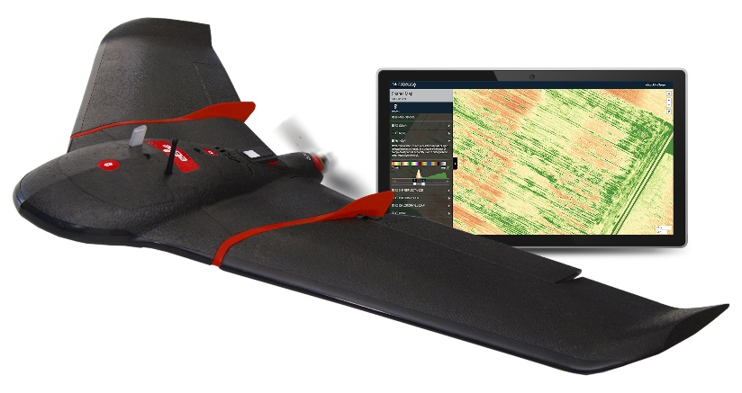
About senseFly
At senseFly, we believe in using technology to make work safer and more efficient. Our proven drone solutions simplify the collection and analysis of geospatial data, allowing professionals in surveying, agriculture, engineering and humanitarian aid to make better decisions, faster.
senseFly was founded in 2009 and quickly became the leader in mapping drones. The company is a commercial drone subsidiary of Parrot Group. For more information, go to www.sensefly.com.
About MicaSense
MicaSense provides a complete solution that empowers growers and agronomists to make data-driven decisions that achieve better crop health, increased productivity, and higher efficiency. Capture a complete picture of crop health with the MicaSense RedEdge sensor and see what you’ve been missing by processing the data in MicaSense Atlas, our cloud-based analytics platform.

MicaSense was founded in 2014 and is based in Seattle, Washington. To learn more about our suite of products, integrations, and partnerships go to www.micasense.com.
Press contacts:
Jessica Sader
Marketing & Events Coordinator, senseFly
Tel: +1 (202) 450 1511
Email: Jessica.sader@sensefly.com

Kelly Osterhout
Marketing and Communications Manager
Tel: +1 206.819.1590
Email: kelly@micasense.com

